# *Jenkins master slave configuration*

Here we setup to Jenkins master slave configuration in aws ec2 server

**Module-1**

Crate and run a two ec2 instance in aws

Prerequisite:-

We will be using all options which are eligible under tha aws free tire account.

To follow along this tutorial create free tire eligible account in aws.

Setup to create two new ec2-instance

go to aws console and seletct create instance

choose any amazon machine image for linux

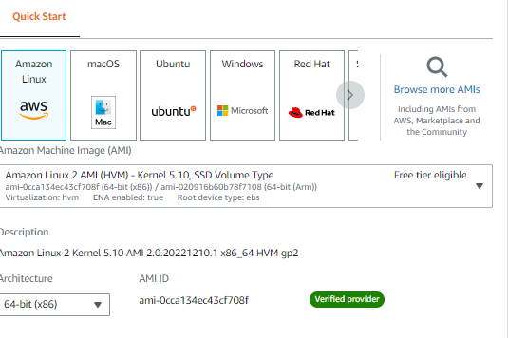

Select instance type (t2.micro)

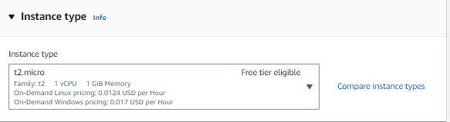

. In Add Storage page, enter the volume size (Ex – 16 GB) and click on Next.

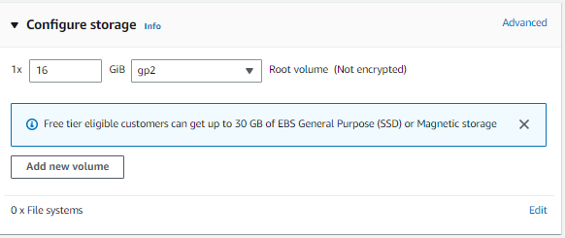

Click add tag givename for ec2 instnce

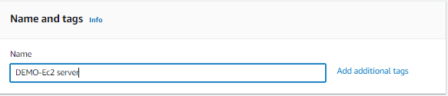

Select and Create new key pair for instance

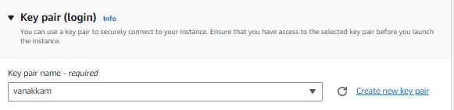

Create security group for instance

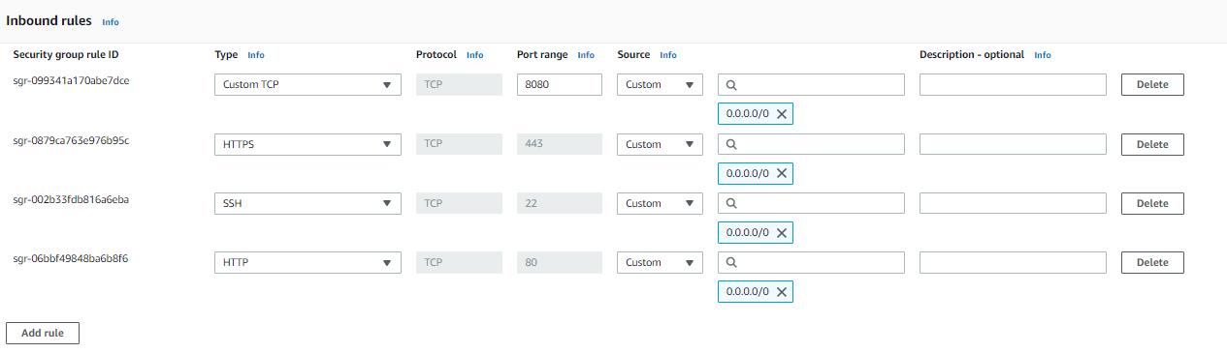

Click on launch instance then we will see tha running status

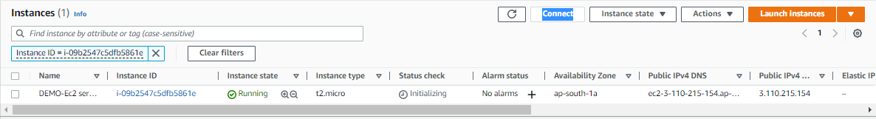

Then connect instance with your terminal (local)

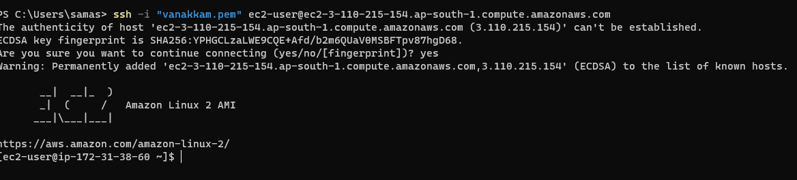

**Module-2**

setup a Jenkins build server on aws ec2

Prerequisite:-

1. Aws two ec2 instance are running.
2. Connect to your ec2 instance with SSH.

Download and install Jenkins:

Add tha Jenkins repo using this command

sudo wget -O /etc/yum.repos.d/jenkins.repo https://pkg.jenkins.io/redhat-stable/jenkins.repo

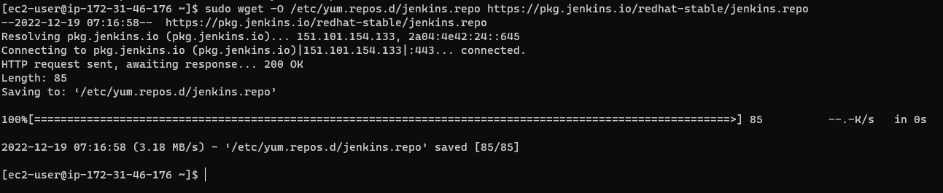

Import a key file from Jenkins-CI to enable installation from the packages

*sudo rpm --import* [*https://pkg.jenkins.io/redhat-stable/jenkins.io.key*](https://pkg.jenkins.io/redhat-stable/jenkins.io.key)



Install Jenkins by using this command

*Sudo yum –y install jenkins*



Install java for Jenkins by using this command

sudo amazon-linux-extras install java-openjdk11



Then start and enable Jenkins

*Sudo systemctl start Jenkins*

*Sudo systemctl enable Jenkins*

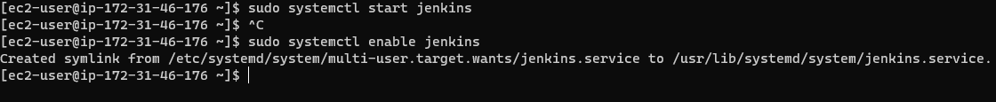

Then copy your demo 1server instance public ip

Paste on tab with port 8080 then browse

It will show the Jenkins home like this

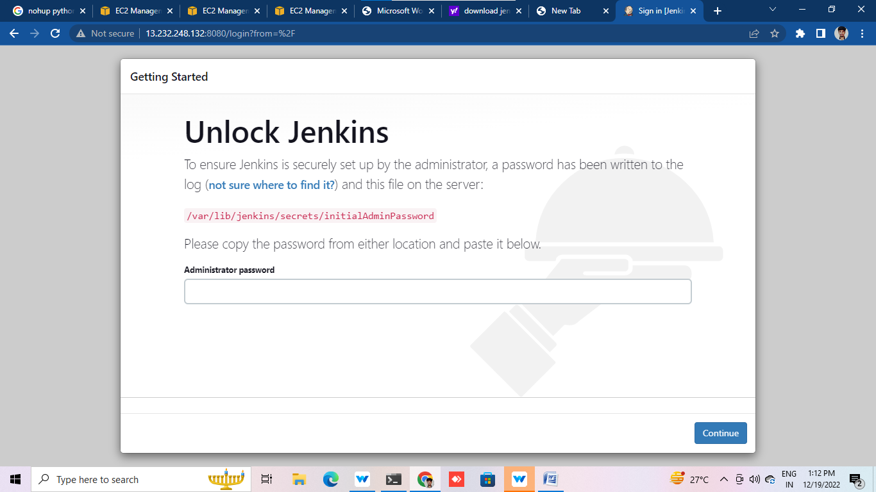

Give Administrator password by using this command

Sudo cat /var/lib/jenkins/secrets/initialAdminPassword



Copy and paste on Jenkins administer password

Then click continue it will open customize Jenkins page

Select install suggested plugins

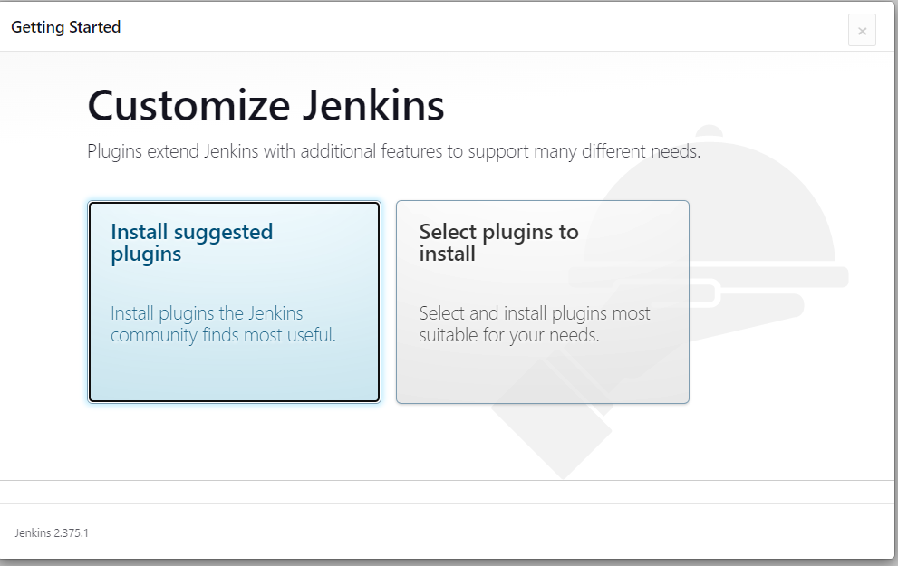

**Module-3**

Jenkins master slave configuration in aws ec2 server

Prerequisite:-

1. Launch two aws ec2 instance (module-1)
2. Configuration Jenkins on ec2 linux instance which will act as master node
3. Second ec2 linux server will act as a slave node for Jenkins

***Configuration Jenkins slave node :-***

* sudo useradd jenkins-slave3
* sudo su - jenkins-slave3
* ssh-keygen -t rsa -N "" -f /home/jenkins-slave3/.ssh/id_rsa
* cd .ssh
* cat id_rsa.pub > authorized_keys
* chmod 700 authorized_keys

***Configuration Jenkins master node :-***

* sudo mkdir -p /var/lib/jenkins/.ssh
* cd /var/lib/jenkins/.ssh
* cd ..
* sudo chmod 777 .ssh
* cd .ssh
* sudo ssh-keyscan -H SLAVE_NODE_PRIVATE_IP >>/var/lib/jenkins/.ssh/known_hosts
* sudo chown jenkins:jenkins known_hosts
* sudo chmod 700 known_hosts

Configure New Node in Jenkins:

1. Click on Manage Jenkins.

2. Click on Manage Nodes and Clouds

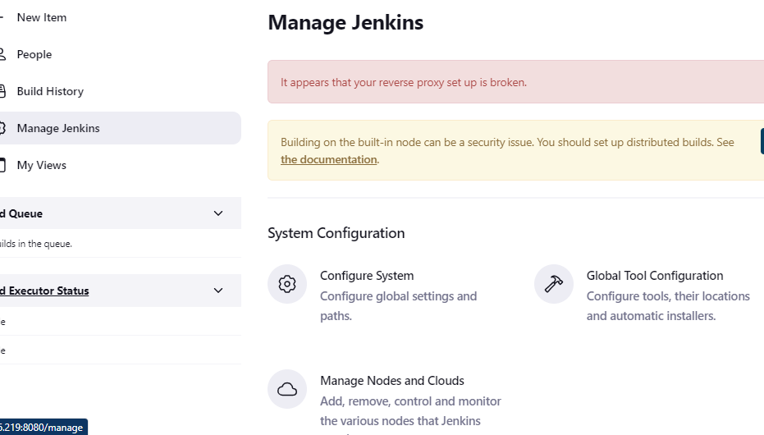

3. Click on New Node

4. Enter Node name and select Permanent Agent. Click OK 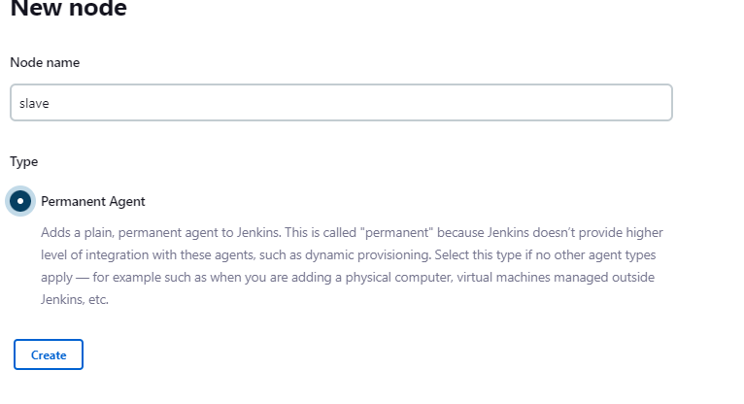

5. Enter node configuration details as shown below.

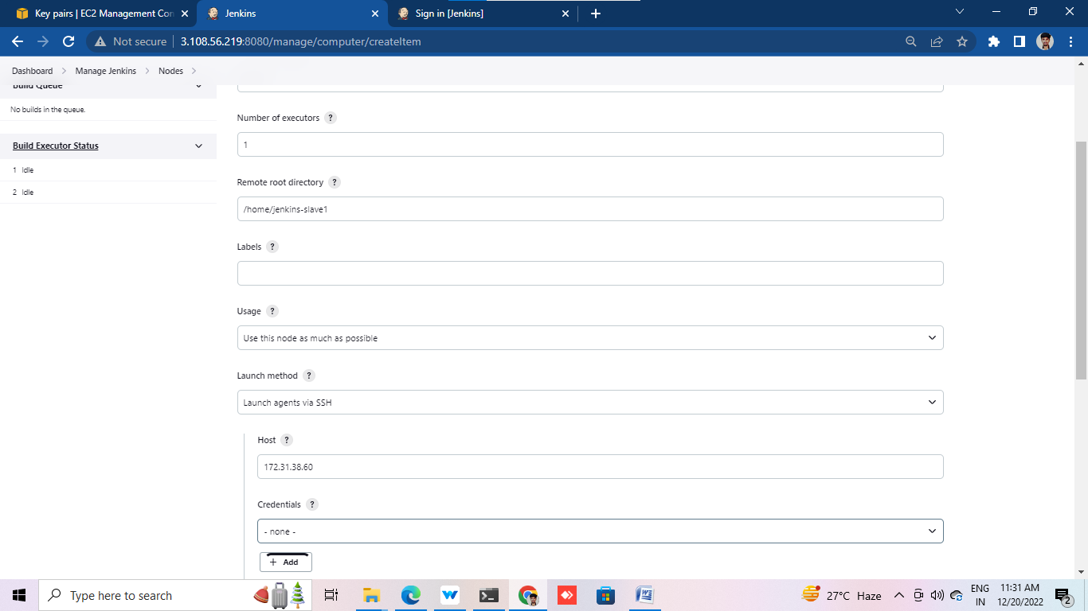

6. In Credentials, Click Add -> Jenkins

7. In Add Credentials, choose kind as “SSH Username with private key”

8. In Username field, enter the same username which we created on Slave

Node – jenkins-slave1

9. In Private Key, choose Enter directly

10. Go to Slave EC2 server and copy the private key.

sudo su - jenkins-slave1

cd .ssh

more id_rsa

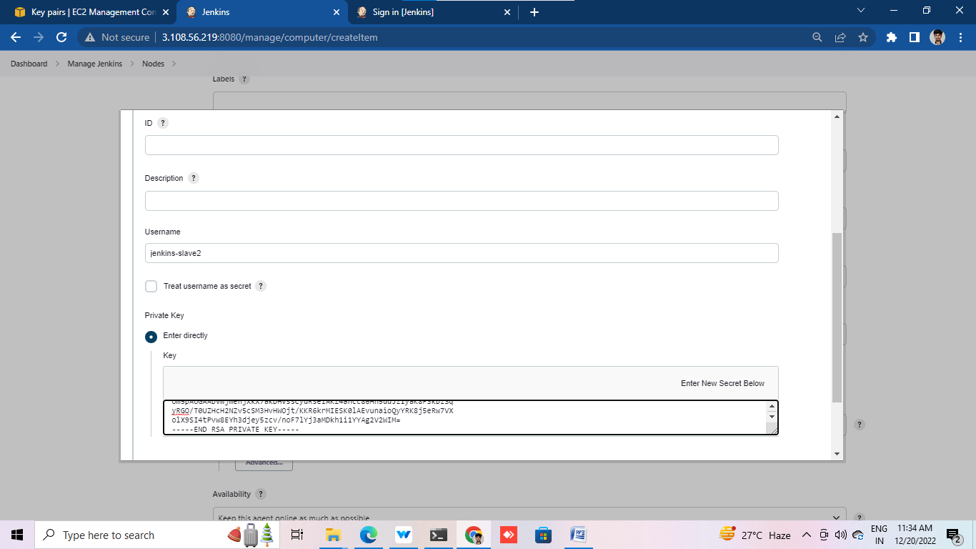

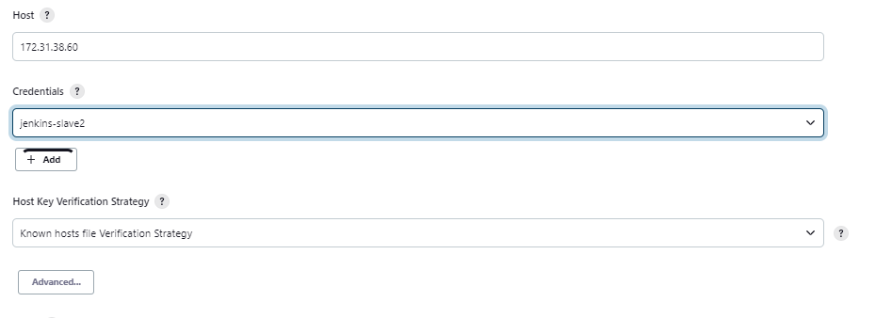

11. Paste the key in the Private key field in Jenkins.

12. Click on Add.

13. In the Node Configuration page choose the new credential.

14. Click on Save

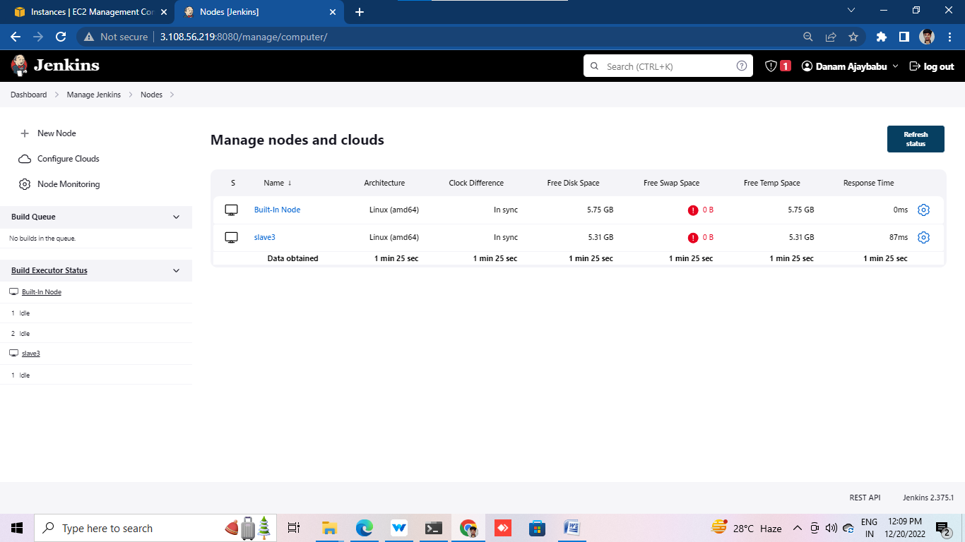

15. Click on the new node (slave1) and select “log”.

16. “Agent successfully connected and online” is displayed in the logs. 